2026 Application Guidelines
Special Selection for Overseas Residents

1. Schedule
This special selection will be held in January - February 2026 (“January – February Selection Process”). Successful applicants will be admitted on April 1, 2026.

Date/Deadline | Tasks & Events
[January – February Selection Process] | Tasks & Events
November 25, 2025 | Deadline for eligibility screening (Eligibility screening is required for those who fall under the category (4) of the requirement of eligibility. See also “3. Eligibility for Admission.”)
December 1, 2025 | Examination fee payment form opens
December 1, 2025 | Examination application opens
December 11, 2025 | Deadline for payment of examination fee and application documents as electronic files via e-mail
December 12, 2025 | Deadline for all application documents
January 29, 2026 – January 30, 2026 | Oral examination
February 13, 2026 | Announcement of examination results
After February 13, 2026 | Enrollment procedure guidelines will be sent out to the successful applicants
March 3, 2026 | Submission deadline for enrollment procedure documents
April 1, 2026 | Date of enrollment
Notes: The dates and times listed in this document are in Japan Standard Time (JST).

2. Number of Students to be Accepted
The following master’s program at the Degree Programs in Systems and Information Engineering is recruiting students in this special selection.

Program | Number of students to be admitted
Master’s Program in Computer Science | A few

3. Eligibility for Admission
- Applicants who have completed 16 years of education and earned a bachelor’s degree, or expected to graduate and receive the bachelor’s degree by March 2026
- Individuals who have completed less than 16 years of school education in a country other than Japan and have been awarded or are expected to be awarded a degree equivalent to a bachelor’s degree by March 2026 after completing a course of at least three years of study at a university or other institution accredited by a foreign government or related organization at that country (Eligibility requirement (2); prior confirmation of the eligibility required)
(3) Applicants who are 22 years or older as of March 2026, and recognized as having academic competency equivalent to university graduates, as a result of the eligibility screening conducted by UT (Eligibility requirement (3); prior confirmation of the eligibility required)

Note: If you have any questions about your eligibility or would like to be screened, please contact us individually at sysinfo.admission@un.tsukuba.ac.jp.

4. Fees & Tuition
(1) Examination Fee
30,000 Japanese Yen (non-refundable)

The examination fee must be paid before applying. Your application will be invalid if the payment is delayed. The examination fee is non-refundable after submission of the application documents. Payment can be made by credit card (VISA, MasterCard, JCB, American Express) by following the steps below.

1) Visit E-shiharai.net website linked below during the designated payment period.
https://e-shiharai.net/english/?schoolcode=OPU5100850000000

Payment period: December 1, 2025
- December 11, 2025 (JST)

2) Top page | Click "Examination Fee."
3) Terms of Use and Personal Information Management | Please read the Terms of use and Personal Information Management. Click "Agree" button in the lower part of the page if you agree with the terms.
4) School Information | Read the information carefully and click "Next."
5) Category Selection | Choose First – Forth Selection category and click “Add to Basket.” The First Selection will be “Degree Programs in Systems and Information Engineering.” In the Forth Selection, choose your desired program.
6) Basket Contents | Confirm the contents and click “Next.”
7) Basic Information | Input the applicant’s basic information. Choose your credit card and click “Next.”
8) Credit Card Information | Input Credit Card Number (15 or 16-digits), Security Code and Expiration date.
9) Payment Result | Confirm all the information displayed and click “Confirm.”
10) Credit Card Payment Completed | Click “Print this page” button and print out “Result” page. Both the printed page and its PDF version (Save the “Result” page as a PDF file or scan the printed document to PDF) are required to be submitted. See also No. 8 in “6. Documents to Be Submitted.”

Note: The examination fees will not be charged for foreign students who are supported by the Japanese Government (Monbukagakusho: MEXT) scholarships.

(2) Admission Fee
282,000 Japanese Yen (non-refundable)

(3) Tuition for the First Year
The tuition rates are subject to change. The tuition of subsequent years will be the same as the first year of enrollment unless the tuition rates are revised.

Semester | Amount
Spring AY 2026 (April 2026 – September 2026) | 267,900 JPY
Fall AY 2026 (October 2026 – March 2026) | 267,900 JPY
Total amount per year | 535,800 JPY

*JPY = Japanese Yen

5. Application Procedures

Before Applying
Before applying, applicants must contact a faculty member and obtain consent to become their prospective supervisor (the person who gives them academic instructions after enrollment).
For the lists of faculty members and their fields of research, see:
Faculty Directory: https://www.sie.tsukuba.ac.jp/fac_search2/
Faculty List: https://www.sie.tsukuba.ac.jp/eng/org/staff/

International students who plan to apply for the following program will need a “reference number” to complete the application (It is a required item on the application form). The reference number will be issued via the prospective supervisor. Since it will take some time to obtain a reference number, please contact your desired faculty member as soon as possible.

- Master’s Program in Computer Science

Apply for Eligibility Screening
Those who fall under the category (2) or (3) of the requirement of eligibility (See “3. Eligibility for Admission”) are required to undergo eligibility screening.
Apply for eligibility screening via e-mail at sysinfo.admission@un.tsukuba.ac.jp by the following deadline.

Deadline: November 25, 2025 5:00 PM (JST)
Note: The deadlines are strictly observed. Applications received after the deadline will not be accepted.
Pay the Examination Fee
The examination fee must be paid before applying. The payment period is as follows
Payment period: December 1, 2025 - December 11, 2025 (JST)
See also “4. Fees & Tuition.”
Apply for Entrance Examination
All applicants are required to submit the entrance examination application documents during the following period. In addition to submitting the application in electronic format, the original documents must also be sent by mail. Both must be completed within the application period.
- Electronic files Submission Deadline: December 11, 2025 5:00 PM(JST)
- Original documents Deadline: December 12, 2025 5:00 PM (JST)

Note:
1) The deadlines are strictly observed. Applications received after the deadline will not be accepted.
2) You cannot change the desired program from one to another after the submission of application documents.
See “7. Examination Schedule, Announcement of Acceptance & Enrollment Procedures” for subsequent procedures

[E-mail address]
Please send all application documents to be submitted electronically to the email address below.
sysinfo.admission@un.tsukuba.ac.jp

[Mailing Address]
Send all the application documents to be submitted via a tracked delivery service to the address below.
Graduate Support
Academic Service Office for Systems and Information Engineering Area
University of Tsukuba
1-1-1 Tennodai, Tsukuba, Ibaraki 305-8573 Japan

6. Documents to Be Submitted
Please read the lists and notes below carefully and prepare the necessary documents for application.
Documents that require the original to be mailed are marked 'Required' in the 'Original copy/ Printed document' column in the table below. For documents not marked 'Required' in this column, only electronic data shall be submitted.
Your completed application form and other supporting documents will not be returned to you.
For certificates that cannot be reissued, please submit a copy certified by the issuer or an official institution. See below picture for the details.
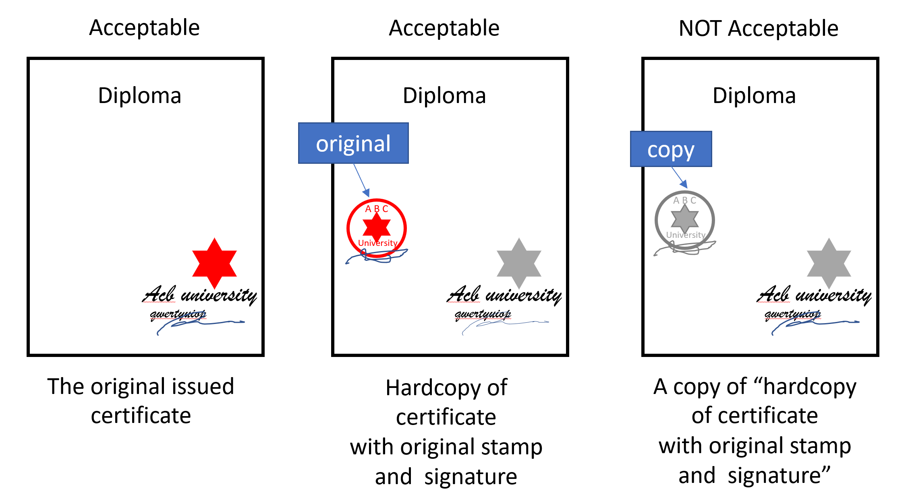

If your university does not issue paper certificates, digital certificates will be accepted on the condition that the following 1 and 2.
1) URL of an online verification service that can verify the authenticity of the digital certificates
*Those that cannot be accessed from outside (e.g., those that require the use of the VPN of your university or cannot be accessed without an account at your university) are not acceptable.
2) URL of the official web page indicating that your university is using such online verification service

If you are unable to obtain a photocopy that meets our requirement, please submit the original document with a return request. “Return request form” will be provided individually. Please let us know if needed.
Regardless of the above, the External English Test Score Sheet will NOT be returned. Also, we will not provide you with a photocopy after submission. Please make your own copy and keep them before submission if necessary.

[Electronic files] Submission Deadline: December 11, 2025 5:00 PM(JST)
[Original documents] Submission Deadline: December 12, 2025 5:00 PM (JST)

No. | Document | Electronic file (Format) | Original document | Instructions
1 | Application Form | Required  (XLSX) | - | Use the prescribed form.  --  A printed document is not required.
2 | [Expected] Graduation Certificate/  [Expected] Degree Certificate | Required  (PDF) | Required | Submit the certificate of [expected] graduation and degree certificate to certify that you have or expected to achieve a bachelor’s degree.  The document(s) must clearly indicate the date of enrollment and [expected] completion, the type and name of the degree.
3 | Academic Transcript | Required  (PDF) | Required | Submit an official academic transcript issued by the university that awarded/will award the most recent degree which is required in “3. Eligibility for Admission.” The document must cover all academic years in the said university. If any credits were transferred from another school, an academic transcript issued by that school is also required.
4 | Research Plan | Required  (PDF) | - | Use the prescribed form.  Summarize your research plans in approximately 1000 words in English.  --  A printed document is not required.
5 | Examination Fee Payment Proof Document | Required  (PDF) | Required | Please submit the "Result" page displayed on the E-shiharai.net website when the payment of examination fee is completed. See also “4. Fees & Tuition.”
6 | Letter of approval to take the entrance examination | If applicable  (PDF) | If applicable | Those who fall under either or both of the following items must submit the letter of approval to take the entrance examination:  1) Students who are currently enrolled in a university and are NOT expected to complete the enrolled course before the desired date of enrollment in UT (i.e. April 1, 2026) must submit a letter of approval for them to take UT’s entrance examination, issued in the name of the president of the university or the dean of graduate school. Any format is acceptable.  2) Full-time workers at a company or a government agency must submit a letter of approval from them to take UT’s entrance examination, issued by their manager. Any format is acceptable.
7 | ID Photo | Required  (JPEG) | - | Your ID photo must be: 40 x 30 mm in size; facing forward and looking straight at the camera; no hats or other objects that obscure your face. The photo quality must be: clear and in sharp focus; taken within last 3 months. Submit the digital image in JPEG format.  --  Printed photo is not required.
Notes:
1) If your current name is different from that on the documents you submit (for example, because of marriage), you will be required to submit proof of your name change (e.g., copy of marriage license).
2) All documents must be written in Japanese or English. Otherwise, attach a Japanese or English translation.

7. Examination Schedule, Announcement of Acceptance & Enrollment Procedures

See “5. Application Procedures” for precedent procedures
Examination
Applicants will be selected based on screening of the application documents and oral examination.
1) The oral examination will be conducted during the following period via Skype, Zoom or other video conferencing tools.

Examination Period: January 29, 2026 – January 30, 2026
2) Follow instructions from the degree program, that will determine the date and location of the oral examination.
3) Applicants will be asked about their research plan, related knowledge and skills.

Announcement of Examination Result
February 13, 2026
The result of examination will be announced individually after the oral examination. An acceptance letter will be sent to successful applicants on the same day by e-mail.

Receive Enrollment Procedure Guidelines  After February 13, 2026  Successful applicants will receive enrollment procedure guidelines, which contain an acceptance letter and documents to be submitted before enrollment. Follow the instructions in the guidelines. | Obtain a Visa  Applicants with foreign nationality must acquire a status of residence which is suitable for admission, in accordance with the Immigration Control and Refugee Recognition Act (Cabinet Order No. 319 of 1951), before beginning enrollment procedures. Those who wish to enroll in UT as an international student must obtain a “Student” visa and enter Japan with a residence status of “Student.”  Obtain a Letter from Employer  Full-time workers need a document or a letter from their employer to prove that the person is available to complete the program (e.g. an order for a training course, a letter of leave of absence or an approval letter).
Admission Procedure to Confirm Enrollment
Deadline: March 3, 2026

You need to complete the procedure via website by the deadline. Some are requested to submit additional certificates via postal mail. Please follow the instructions.
Enrollment
April 1, 2026

8. Handling of Personal Information
Applicants’ personal information obtained from the application documents and the results of the entrance examination will be used for the affairs concerning admission and screening. UT may also process the information so that it is not personally identifiable and use it for research and study aimed at improvement of the admission procedure and the university education.

9. Security Export Control
The University of Tsukuba has established the University of Tsukuba Rules on Security Export Control in accordance with the Foreign Exchange and Foreign Trade Act, and conducts strict examinations for acceptance of international students. Applicants who fall under any of the conditions set out in the said regulations may be unable to enter their desired program.

10. Contact
1) If you have any questions about this application guidelines, please contact us:
Graduate Support, Academic Service Office for the Systems and Information Engineering Area
1-1-1 Tennodai, Tsukuba, Ibaraki 305-8573 Japan
Monday – Friday (except university holidays),
from 9:00 AM to 5:00 PM (except 12:15 PM - 1:15 PM) (JST)
E-mail: sysinfo.admission@un.tsukuba.ac.jp

2) If you have any questions about curriculum or research field, contact the degree program.

Master’s Program in Computer Science
E-mail: exam@cs.tsukuba.ac.jp

