Doctoral Thesis Specification
１． Text
(1) The sheet is A4-size from the side.(Single- or double-sided)
・ free style and character
・ The margins are free-form.
(2) Attach the bibliography at the end of thesis.

２． Cover
(1) Please check next sample and create it.
(2) Month and Year is the date of completion (Month ：September or March).
・ Make sure not to write the date of submission.

３． Inside Cover
Please don’t forget to attach an inside cover. Please check next sample pages and attach the inside cover to the first page of the thesis.
- Example of a simple thesis
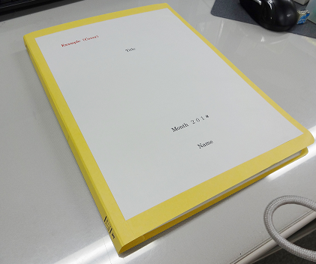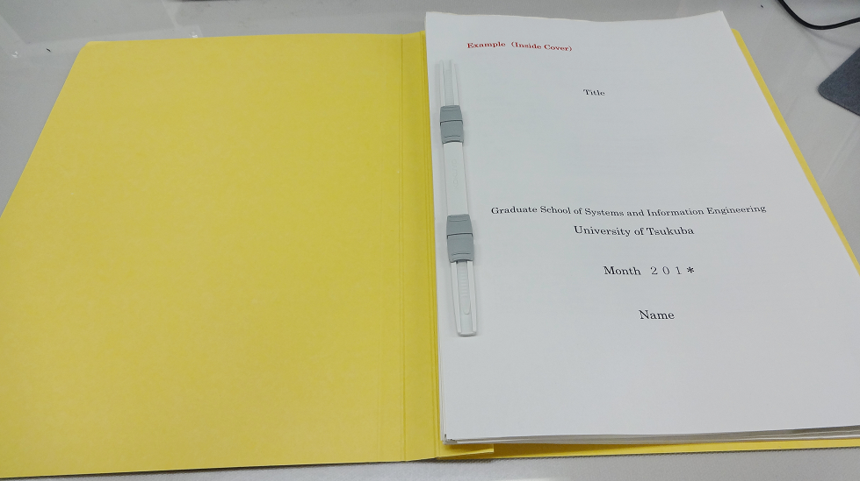
４． Submission to thesis for publication to internet
After passing the final examination with simple bound thesis, please record thesis data for Internet publication to a CD has been prepared by university and submit it to adviser.

Title
Example（Cover）

Month | ２０＊＊

Name
Month and Year in the date of completion
(Month:September or March)
Title
Example（Inside Cover）

Graduate School of Science and Technology
Degree Programs in Systems and Information Engineering
University of Tsukuba

Month | ２０＊＊

Name
Month and Year in the date of completion
(Month:September or March)

