The Example of Thesis
at the Graduate School
of Science and Technology
Degree Programs in Systems and Information Engineering

Taro Tsukuba
（Master’s Program in ○○○○）

Advised by Daijiro Tsukuba

Submitted to the Graduate School of Science and Technology
Degree Programs in Systems and Information Engineering
in Partial Fulfillment of the Requirements for the Degree of Master of ○○○○○
at the University of Tsukuba

Month 20＊＊

Abstract

This is a sample document for writing a thesis which will be submitted to the Degree Programs in Systems and Information. The main purpose of this document is to reduce the author's trouble in making title. Of course you can create your title page from scratch. But your style must fulfill the requirements such as margins.

Contents
Chapter 1 1
Chapter 2 2
  - Title 2
  - Body 2
Acknowledgements 4
Bibliography 5

List of Figures
Figure 2.1 Example of Figure 3

Chapter 1 Introduction
This is a sample document for writing a thesis which will be submitted to the Degree Programs in Systems and Information. The main purpose of this document is to reduce the author's trouble in making title. Of course you can create your title page from scratch. But your style must fulfill the requirements such as margins.

This document is also prepared for intention of unifying the thesis style. You can write your thesis based on this document. This document does not include how to write good thesis. So, you should consult advisor(s) about the concrete example of thesis and other details.

Chapter 2 Format
In this chapter, we show how to fill the title and body.

Title
Title page has to include Title and Author and Major Field and Advisor and Date.

Body
Body should be described in single column.

Table 2.1 and Figure 2.1 are the examples. Tables and Figures must be shown with a caption. A caption for table will be put at the top of the table. A caption for figure will be put at the bottom of the figure. Tables and Figures should be referred in the context.

Table 2.1 Sample of Table

Year | 1st | 2nd | 3rd | 4th
1995 | 85 | 92 | 86 | 88
1996 | 83 | 89 | 90 | 102
1997 | 88 | 87 | 91 | 102
1998 | 144 | 93 | 90 | 115

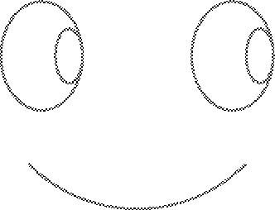

Figure 2.1 Example of Figure

See Help file or related document of Microsoft Word [1].

References are numbered and referred in the context. We will show concrete example of referring to a related work as[2].

Acknowledgements

Bibliography
- Steve Ballmer, Jim Allichin and Bill Gates, Office XP: Advanced Technique and Experiments of Office Soft wares, Journal of Microsoft Product Information, Vol. 3, Number 2, pp. 129-138, November 2000 (fictitious paper).

- Randal E. Bryant, Graph-based algorithms for Boolean function manipulation, IEEE Transactions on Computers, Vol. C-35, No. 8, pp. 677-691, August 1986.

